**Lab 6 – Aggregate Function**

**Keerthana Shivakumar**

**PES1UG20CS204**

1. Find the average distance between subsequent stations for every train

–  [SELECT](http://localhost/phpmyadmin/url.php?url=https://dev.mysql.com/doc/refman/8.0/en/select.html) route_info_204.Train_No, ([AVG](http://localhost/phpmyadmin/url.php?url=https://dev.mysql.com/doc/refman/8.0/en/aggregate-functions.html%23function_avg)(route_info_204.distance)) AS avg_distance FROM route_info_204, train_204 WHERE route_info_204.Train_No = train_204.Train_no GROUP BY (route_info_204.Train_No);

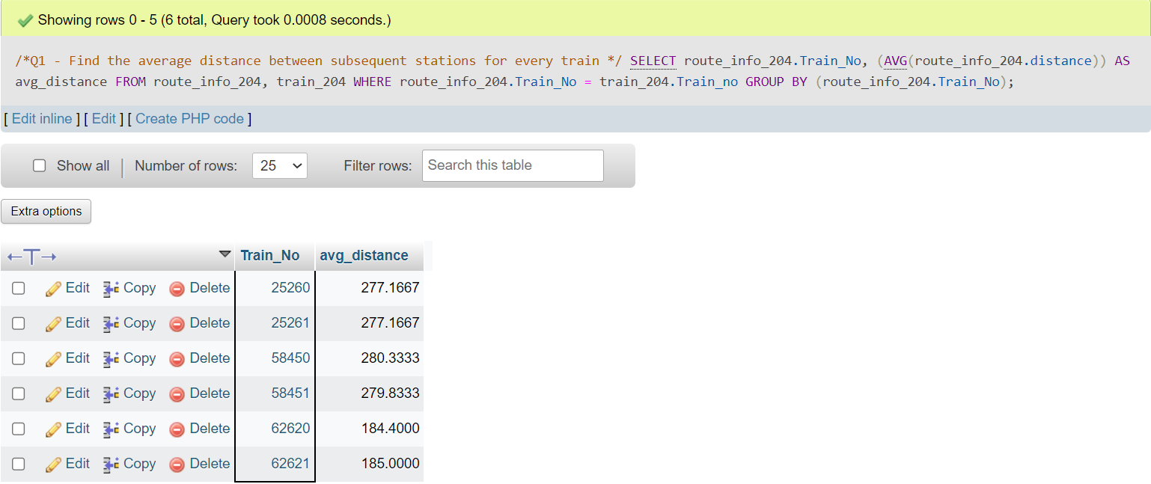

2. Find the average distance between subsequent stations for every train and display them in descending order

[SELECT](http://localhost/phpmyadmin/url.php?url=https://dev.mysql.com/doc/refman/8.0/en/select.html) route_info_204.Train_No, ([AVG](http://localhost/phpmyadmin/url.php?url=https://dev.mysql.com/doc/refman/8.0/en/aggregate-functions.html%23function_avg)(route_info_204.distance)) AS avg_distance FROM route_info_204, train_204 WHERE route_info_204.Train_No = train_204.Train_no GROUP BY (route_info_204.Train_No) ORDER BY avg_distance DESC;

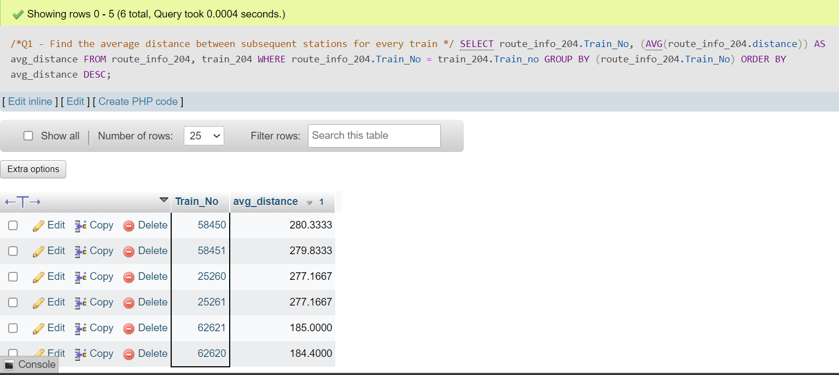

3. Display the list of train numbers and the distance traveled by each in descending order of the distance traveled

[SELECT](http://localhost/phpmyadmin/url.php?url=https://dev.mysql.com/doc/refman/8.0/en/select.html) route_info_204.Train_No, ([SUM](http://localhost/phpmyadmin/url.php?url=https://dev.mysql.com/doc/refman/8.0/en/aggregate-functions.html%23function_sum)(route_info_204.distance)) AS sum_distance FROM route_info_204, train_204 WHERE route_info_204.Train_No = train_204.Train_no GROUP BY (route_info_204.Train_No) ORDER BY sum_distance DESC;

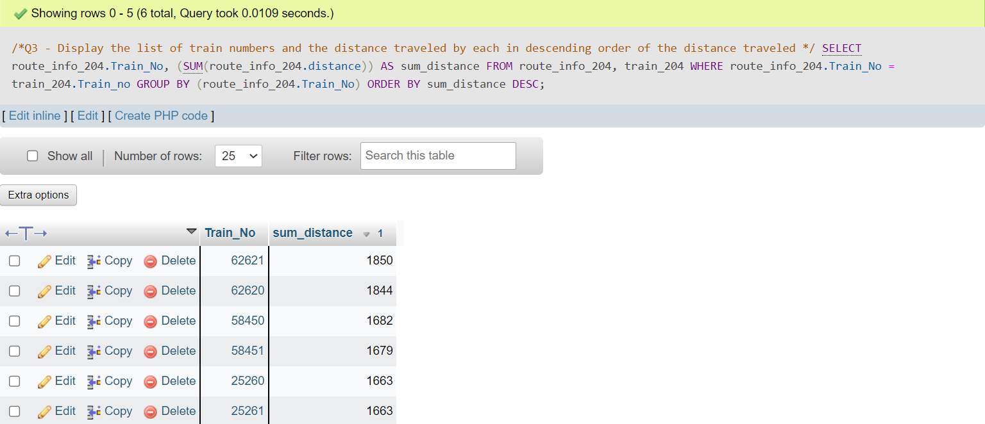

4. List those trains that have maximum and minimum number of compartments as train name and number of compartments

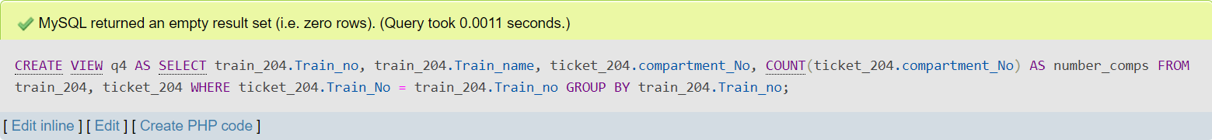

[SELECT](http://localhost/phpmyadmin/url.php?url=https://dev.mysql.com/doc/refman/8.0/en/select.html) Train_name, number_comps FROM q4 WHERE number_comps [IN](http://localhost/phpmyadmin/url.php?url=https://dev.mysql.com/doc/refman/8.0/en/comparison-operators.html%23function_in)( ([SELECT](http://localhost/phpmyadmin/url.php?url=https://dev.mysql.com/doc/refman/8.0/en/select.html) [MAX](http://localhost/phpmyadmin/url.php?url=https://dev.mysql.com/doc/refman/8.0/en/aggregate-functions.html%23function_max)(number_comps) FROM q4), ([SELECT](http://localhost/phpmyadmin/url.php?url=https://dev.mysql.com/doc/refman/8.0/en/select.html) [MIN](http://localhost/phpmyadmin/url.php?url=https://dev.mysql.com/doc/refman/8.0/en/aggregate-functions.html%23function_min)(number_comps) FROM q4) );

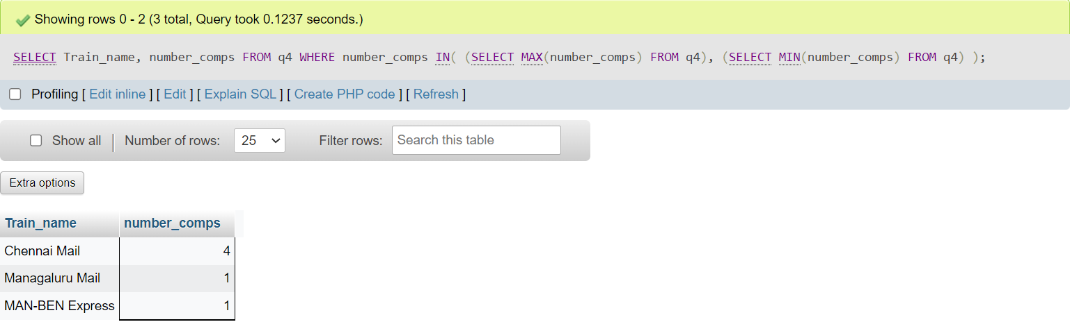

5. Display the number of phone numbers corresponding to the user_id(s) ADM_001, USR_006, USR_10

[SELECT](http://localhost/phpmyadmin/url.php?url=https://dev.mysql.com/doc/refman/8.0/en/select.html) user_phone_204.User_ID, [COUNT](http://localhost/phpmyadmin/url.php?url=https://dev.mysql.com/doc/refman/8.0/en/aggregate-functions.html%23function_count)(*) FROM user_phone_204 WHERE user_phone_204.User_ID = 'ADM_001' [OR](http://localhost/phpmyadmin/url.php?url=https://dev.mysql.com/doc/refman/8.0/en/logical-operators.html%23operator_or) user_phone_204.User_ID = 'USR_006' [OR](http://localhost/phpmyadmin/url.php?url=https://dev.mysql.com/doc/refman/8.0/en/logical-operators.html%23operator_or) user_phone_204.User_ID = 'USR_010' GROUP BY user_phone_204.User_ID;

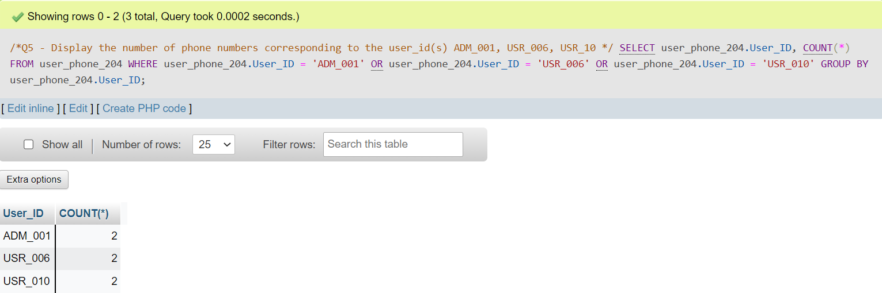

6. Find the average fare per km for each train type specified and display the train type and corresponding average fare per km as ‘Avg_Fare’ in decreasing order of Avg_Fare

[SELECT](http://localhost/phpmyadmin/url.php?url=https://dev.mysql.com/doc/refman/8.0/en/select.html) fare_204.train_type, [AVG](http://localhost/phpmyadmin/url.php?url=https://dev.mysql.com/doc/refman/8.0/en/aggregate-functions.html%23function_avg)(fare_204.fare_per_km) AS Avg_Fare FROM fare_204 GROUP BY fare_204.train_type ORDER BY Avg_Fare DESC;

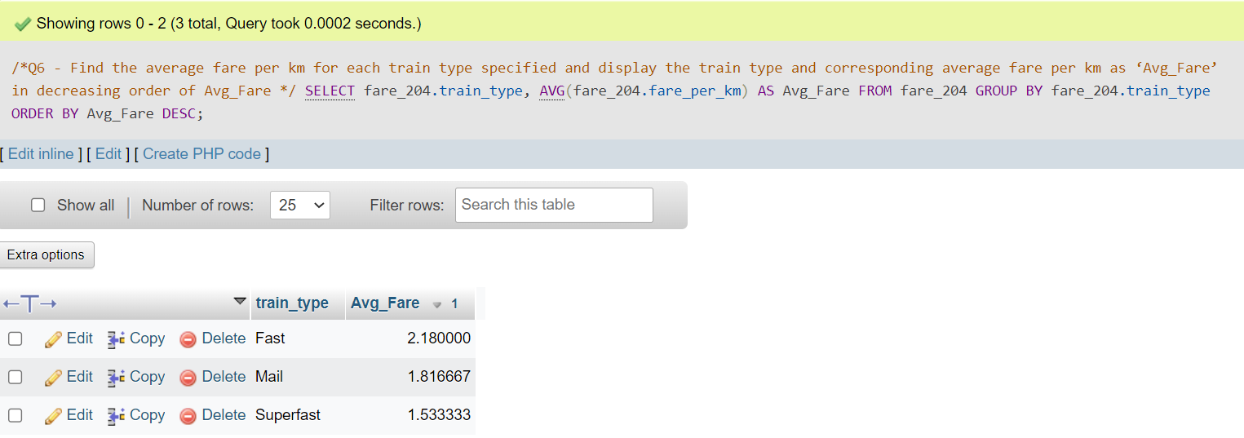

7. Retrieve all details of the oldest passenger.

Query – [SELECT](http://localhost/phpmyadmin/url.php?url=https://dev.mysql.com/doc/refman/8.0/en/select.html) * FROM passenger_204 WHERE ( passenger_204.age =( [SELECT](http://localhost/phpmyadmin/url.php?url=https://dev.mysql.com/doc/refman/8.0/en/select.html) [MAX](http://localhost/phpmyadmin/url.php?url=https://dev.mysql.com/doc/refman/8.0/en/aggregate-functions.html%23function_max)(passenger_204.age) FROM passenger_204 ) [AND](http://localhost/phpmyadmin/url.php?url=https://dev.mysql.com/doc/refman/8.0/en/logical-operators.html%23operator_and)(passenger_204.user_type = 'PSGR') );

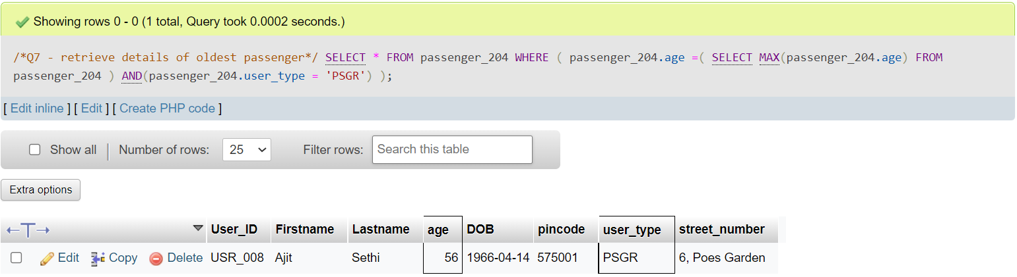

8. Count the number of passengers whose name consists of ‘Ullal’. (Hint: Use the LIKE operator)

Query - [SELECT](http://localhost/phpmyadmin/url.php?url=https://dev.mysql.com/doc/refman/8.0/en/select.html) [COUNT](http://localhost/phpmyadmin/url.php?url=https://dev.mysql.com/doc/refman/8.0/en/aggregate-functions.html%23function_count)(*) FROM ticket_passenger_204 WHERE ticket_passenger_204.Name [LIKE](http://localhost/phpmyadmin/url.php?url=https://dev.mysql.com/doc/refman/8.0/en/string-comparison-functions.html%23operator_like) '%Ullal%';

